## **Software Flow and Game States**

The game will have the following 3 game states: “Main Menu”, “Gameplay”, “Pause”, “Game Over”, and “Victory”.

1. **Main Menu**

This state will be the first state the game enters. The following buttons which leads to different states or pages are displayed to the user:

* “Play” option
* “Exit” option
* “Instructions” option
  + This opens a page containing instructions for the game.
* “Settings” option
  + This page is left empty for this phase.
* “About” option
  + This opens a page containing a summary of the game

1. **Gameplay**

After pressing the “Play” button in the Main Menu state, the game opens the game map where the game takes place.

1. **Pause**

During the “Gameplay” state, the player can enter the “Pause” phase upon hitting the “ESC” key while playing. The gameplay is paused during this state and the game map is darkened. The following buttons are displayed to the player:

* “Resume” button: this button resumes the game and puts the game back in the “Gameplay” state
* “Exit to Main Menu”: this button puts the game back to the “Main Menu” state.
* “Exit Game”: this button terminates the program.

*[Next page]*

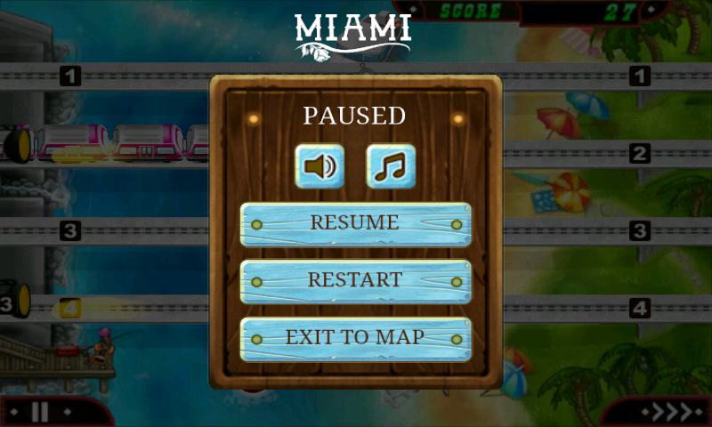

*Figure 1*: Sample of the paused state

1. **Game over**

The software enters this state when the player loses. The map is blurred out with the text “Game Over” displayed. The following buttons are shown on the screen:

* “Retry”: This puts the game back to the “Gameplay” state and restart the gameplay
* “Main Menu”: Go back to “Main menu” state
* “Exit Game”: Terminate the program

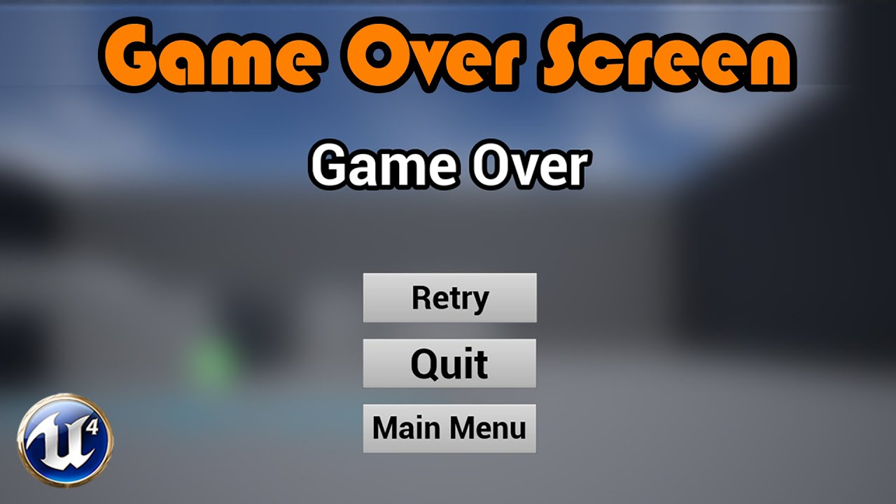

*Figure 2*: Sample of the game over state

1. **Victory**

This game state is entered when the win condition has been met. The game map is blurred and the text “Victory!” is displayed on the screen. The following buttons are also displayed.

* “Retry”: This puts the game back to the “Gameplay” state and restart the gameplay
* “Main Menu”: Go back to “Main menu” state
* “Exit Game”: Terminate the program

## **Win and Lose Conditions**

1. **Win condition:** The player has defeated all enemies. The game enters the “Victory” game state.
2. **Lose condition:** The player has run out of Health Points (HP). The game enters “Game over” game state.

## **Map Layout**

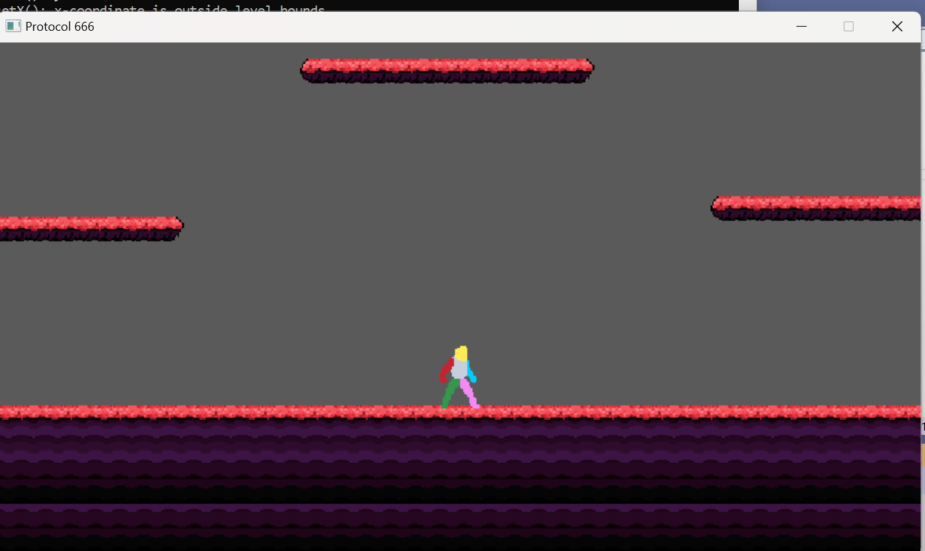

*Figure 3*: Current map layout

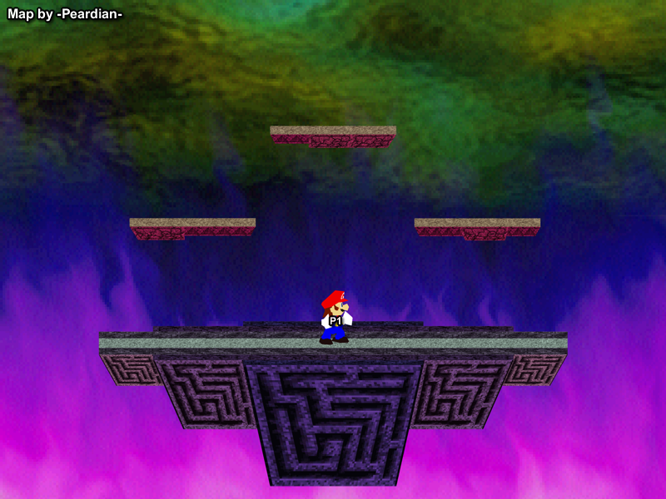

*Figure 4:* Sample map layout

**Dimensions of map**: To be decided.

The game takes place on a terrain with floating platforms all across the map. The player always begins in the center of the terrain. The map only uses 1 type of tile.

## **User Interface**

Gameplay information displayed to the user during “Gameplay” state:

* **Player’s health**: displayed on a “health bar” on the bottom left of the screen.

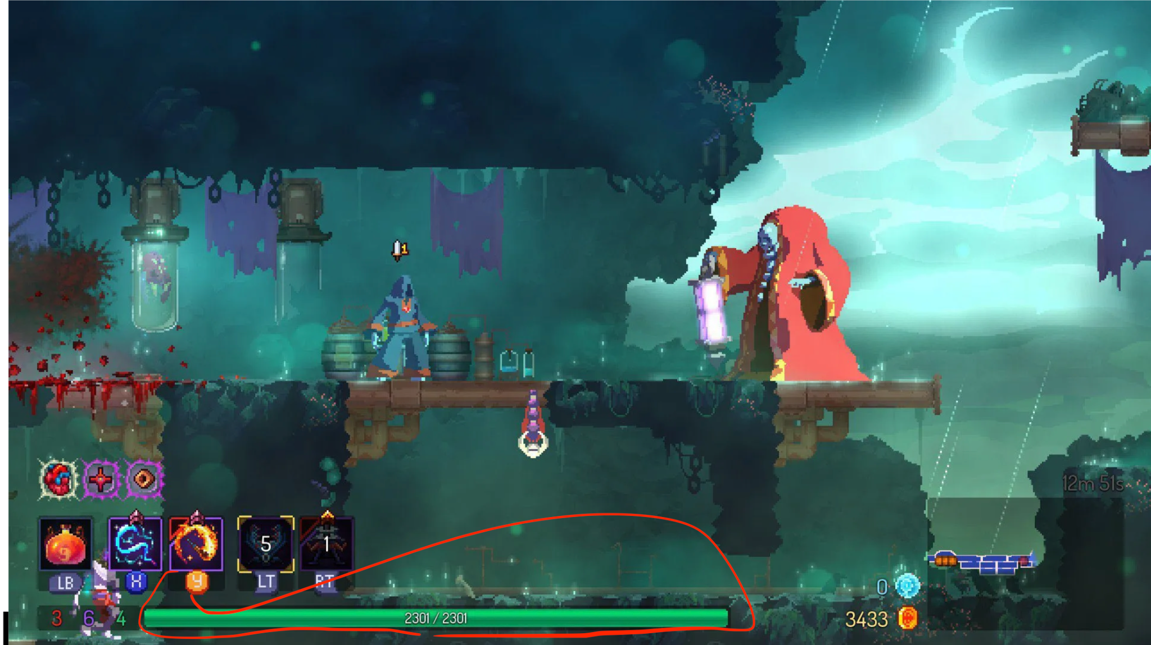

*Figure 5*: Sample health bar for Player object

* **Enemy health:** The remaining health points of enemies are only displayed when the player causes damage to the enemies. This health bar is displayed on top of the enemies health for 5 seconds. If enemy doesn’t take damage for 5 secs, the health bar disappears

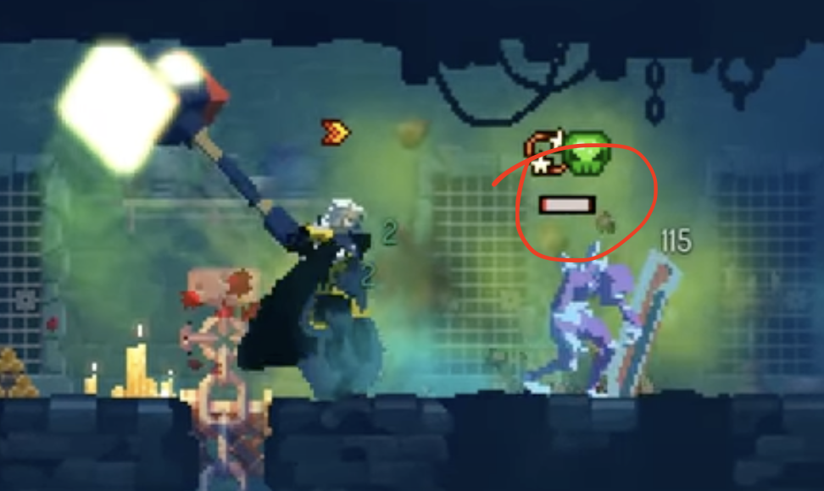

*Figure 6:* Sample health for Enemy object

## **Playable Character**

## 

*Figure 7*: Current playable character

The player can perform the following actions:

* **Run**: this is done using the left/right arrow keys and A/D keys.
* **Jump**: this is done with the up arrow and W keys.
* **Shoot**: done by holding the left mouse button. A cursor will be on the screen and projectiles will fly towards the direction of the cursor the moment the left mouse button is clicked.
  + **Projectile**
    - **Damage:** Each projectile will reduce NPC’s health points by 5. Upon collision
    - **Interaction:** Projectiles disappears upon collision with NPCs, terrains, or when they go out of range (This range will be decided on during play test)
* **Roll:** done by pressing the shift key. The player rolls a short distance towards the direction that they are facing. This can be done both on the ground and in the air. While rolling, the player is invulnerable to taking damage and can move through enemies without collision.

## **Projectiles and Terrains**

**Projectile**

* **Damage:** Each projectile will reduce NPC’s health points by 5. Upon collision
* **Interaction:** Projectiles disappears upon collision with NPCs, terrains, or when they go out of range (This range will be decided on during play test)

**Terrain**

* **Ground:** This is a basic terrain that all characters stand on.
* **Platforms:** Floating terrains that characters stand on or collide with.

## **Non-playable Characters**

### Non-playable characters (NPC) consist of enemies chasing down and eliminating the Player. Enemies will be distinguished into two groups, Goons and Boss.

### **Universal interactions**

Unless indicated otherwise, all Goons and bosses will have the following interactions with the player:

* **Taking Damage from the Player:** all Goons lose HP points when colliding with Player’s bullets (unless they possess special features that alters this interaction).
* **Collision with the player:** deals damage to the Player and knocks the Player back upon collision.
* **Death:** All goons and bosses will despawn when their Health Points reach 0 or below.

### **Goons**

The goal of a Goon’s design is to create an enemy with basic, and low logic actions (perceived by the Player) that consistently threatens the Player without requiring constant pressure on its own elimination.

**Note:**

* *Default* movement logic is defined as
  + *Always run* towards the Player’s x-coordinate.
  + *Jump* when the Player is on a platform with a different y-coordinate than itself.
* *Speed* of each enemy is 2 pixels per frame update unless stated otherwise.
* *Range (Goon-related references, e.g. “within 300 pixels”)* always refers to the range in the x-axis (with the y-range as the enemies’ height). Unless specified otherwise.
* *Proximity* will refer to the distance to the Player, e.g. if the Goon needs to be in the proximity of 100 pixels to attack the Player, the Goon can attack anywhere within the 100 pixels diameter circle of the Player (at the center).
* *Fade, or disappear* refers to a rendered object ceasing to be rendered (usually happens when the object travels a distance, like bullets fading after 200 pixels).

| **Class Name** | **Attack Logic** | **Special feature** | **Interaction with the Player** | **Statistics** |
| --- | --- | --- | --- | --- |
| RangeGoon | *Persistently shoots* bullets towards the Player.  *Stops* *running logic (hence idle while shooting at the Player)* when the Player is within 300 pixels. | *Projectile bullets* will have a fade, or disappearance* range of 350 pixels. | *Self-collision* with the Player makes the Player take damage and is knocked back for 50 pixels.  *Bullet collision* with the Player makes the Player take 10 HP damage and is knocked back for 10 pixels. |  |
| MeleeGoon | *Lunges at the Player* when MeleeGoon is in the range of 150 pixels from the Player. | None | *Self collision* with the Player (without lunge) makes the Player take 10 damage and is knocked back for 10 pixels.  *Lunge collision* with the Player makes the Player take 15 damage and is knocked back for 100 pixels. |  |
| ShieldGoon | Within the range of 50 pixels from the Player, trigger a shove animation targeting the Player. | None | *Self collision* with the Player (without shove) makes the Player take 10 damage and is knocked back for 10 pixels.  *Shove* deals 5 HP damage to the Player, *knocks back* the Player by 100 pixels. |  |
| Kamikaze  -Goon | Within 50 pixels proximity (both x and y range) of the Player, triggers self-explosion. | KamikazeGoon is despawned, after triggering the attack animation. | *Self-explosion* deals 20 HP damage to the Player, *knocks back* the Player by 100 pixels. |  |
| SniperGoon | *Points a laser* indicator at the Player’s center coordinate (x and y), after 100 frames, the laser blinks at 3 frames on and off to indicate the SniperGoon is about to shoot. | *Run* towards the edges of the current platform, ground.  Does not *jump*.  SniperGoon’s bullet will travel at a *higher speed* until it goes out of the Map range. | SniperGoon’s *bullet* deals 40 HP damage if it collides with the Player.  Player’s collision with the SniperGoon makes the Player take 5 HP damage and 10 pixel knockback. |  |

### Boss

*Note: This NPC is omitted for this phase*

### Final notes: